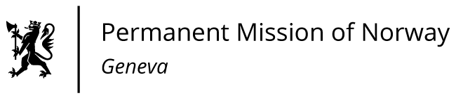

STATEMENT

42nd UPR Session of the Human Rights Council

on the human rights situation in Peru,

as delivered by Ms Sigrun Stigen HOLTER

First Secretary, Human Rights.

Check against delivery
25 January 2023
President,

Norway welcomes the participation of Peru in the UPR process.

We note with concern the current political situation in Peru and call for an immediate stop the use of excessive force by security forces. The rights to freedom of expression and peaceful assembly must be protected. We also call on the government and all political actors to restore calm and ensure an inclusive dialogue with the participation of civil society.

Norway recommends that Peru:

1) intensifies efforts to protect environmental human rights defenders and indigenous rights defenders, including by ratification and implementation of the Regional Agreement on Access to Information, Public Participation and Justice in Environmental Matters in Latin America and the Caribbean, the Escazú Agreement;

2) takes action to protect the territory of isolated indigenous peoples, and employs effective measures to strengthen the implementation of the Indigenous and Tribal Peoples Convention, ILO Convention No. 169;

3) adopts regulatory and budgetary policies to prevent and combat sexual and gender-based violence, [especially against girls and adolescents], and provides substantive redress for victims;

4) decriminalises abortion and develops and implements a comprehensive health care protocol to safeguard sexual and reproductive health and rights with special emphasis on adolescents under 15 years of age with unintended pregnancies;

5) repeals Act no. 31498 and ensures the implementation of comprehensive sexual education throughout the national territory from an intersectional perspective that encompasses gender, interculturality and human rights.

Thank you.

