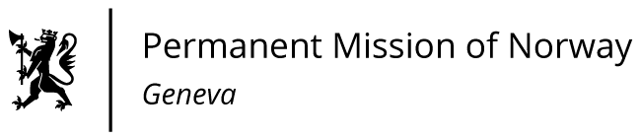

STATEMENT

42nd UPR Session of the Human Rights Council

on the human rights situation in Guatemala,

as delivered by Ms Sigrun Stigen HOLTER

First Secretary, Human Rights.

Check against delivery
25 January 2023

President,
Norway welcomes Guatemala’s participation in the UPR process.
Norway commends Guatemala for the attention given to addressing malnutrition in the 2023 national budget for 2023, but remains concerned about the scale of malnutrition and poverty in the country.
Norway recommends that Guatemala:
1) safeguards judicial independence by ensuring that judges are free of any interference or pressure in the exercise of their functions, and guarantees due process for prosecuted justice operators, journalists and human right defenders, [in accordance with international standards];
2) takes concrete action to guarantee the right of indigenous peoples to prior consultation [in accordance with ILO Convention no. 169], and complies with the reparation measures ordered by the Inter-American Court of Human Rights in the case regarding community radio stations;
3) implements effective policies to combat acute malnutrition among indigenous peoples and other vulnerable groups;
4) decriminalises abortion and guarantees access to sexual and reproductive health and rights for all;
5) implements effective measures to prevent and combat discrimination and violence based on sex, gender identity and sexual orientation, [such as a protocol for law enforcement institutions], and urgently addresses the issue of impunity.
Thank you.

