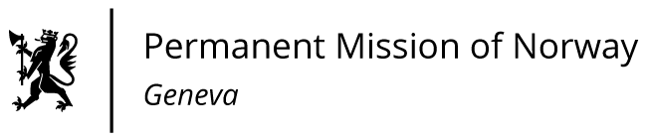

STATEMENT

42nd UPR Session of the Human Rights Council

on the human rights situation in Czechia,

as delivered by Ms Jannicke Graatrud,

Minister, Deputy Permanent Representative.

Check against delivery
24 January 2023

President,

Norway commends Ghana for the progress made since the last UPR process in 2017, and in particular welcomes the adoption of the Right to Information Act, 2019.
Norway is concerned about the reported increased violence and hate speech against the LGBTQI community.
Norway recommends that Ghana:
1) takes concrete steps to protect all vulnerable and marginalised groups from violence and discrimination, by enforcing existing laws that protect all persons without distinction, and by punishing perpetrators and ensuring victims proper access to rehabilitation and remedy;
2) strengthens and enforces laws to protect all girls and women from sexual and gender-based violence and harmful practices, including female genital mutilation and accusations of witchcraft;
3) addresses discrimination against persons with disabilities, including by ensuring implementation of the existing ban on shackling, and re-examines the Rights of Persons with Disabilities Act to ensure coherence with the CRPD [UN Convention on the Rights of Persons with Disabilities];
4) ensures the safety of journalists and media organisations in line with the UN Plan of Action on the Safety of Journalists and the Issue of Impunity;
Thank you.

