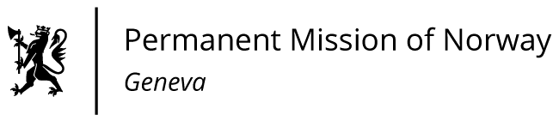

STATEMENT

42nd UPR Session of the Human Rights Council

on the human rights situation in Argentina,

as delivered by Ms Anniken ENERSEN

Minister Counsellor, Human Rights

Check against delivery
23 January 2023

President,
Norway commends Argentina on the adoption of a law on the right to safe and legal abortion, [in line with recommendations made during the UPR process in 2017].

Norway recommends that Argentina:

1) ensures effective implementation of the law on the right to safe and legal abortion, including by disseminating information about the right to legal abortion, facilitating capacity-building for healthcare professionals, and collecting and publicising data at the local and national level regarding the implementation of the law;

2) strengthens efforts to combat gender-based violence, including by ensuring that victims have access to free legal representation;

3) finalises the national action plan on business and human rights, including through broad consultations;

4) takes further steps to ensure indigenous peoples’ right to consultation, and obtain their free, prior and informed consent before proceeding with legal and administrative measures that may affect their rights.
Thank you.

