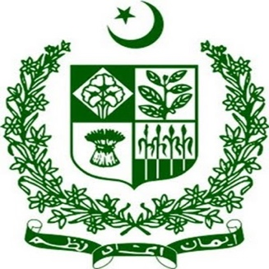
Remarks by Ambassador Khalil Hashmi,
Permanent Representative of Pakistan to the UN, Geneva

Thank you, Mr. President.

I leave the final and concluding remarks to the Minister. I would just like to take this opportunity to thank my colleagues and others who have participated in this interactive dialogue with a constructive spirit.

I want to speak two issues; first the references and insinuations made by one delegation about the state of minorities in Pakistan. I just wanted to say that coming from a country’s representative, this sound is a bit rich, especially when you see even the country concerned not allowing the release or the watching of a BBC documentary which has documented intensely the treatment meted to Muslim minority in Gujrat. The second issue I want to highlight is reference made to the control of territories and terrorism arising from the territories under control of Pakistan. I just want to say that this is unfortunately the parroting of the self-serving canard of “terrorism” by one country which has continued to frame the legitimate struggle of people for realization of their inalienable right to self-determination as “terrorism”.

This is not new neither surprising. This is an old ploy of the occupation regimes. This label is applied regularly in order to dehumanize the people seeking freedom from the oppressive occupiers. This is also a tool used frequently to delegitimize their legitimate struggle for securing the right to self-determination, freedom and justice. The Kashmiri people have long been subjected to these labels with a view to justifying the imposition of state terrorism, and suppression of their basic rights and freedoms. Yet the people of Jammu & Kashmir remain resolute in their just and peaceful struggle for their rights, dignity and freedom from tyranny.

Let me also add that it is not just the Kashmiri people that have long suffered at the hands of this state terrorism. The concerned State has the dubious distinction of aiding, abetting and financing terrorism in each of its neighbouring countries.

With this I would like to end but before I do that, I would just like to also add that we have in fact the Minister is sitting here and our leadership has handed over a comprehensive dossier to the United Nations and several other countries which contains concrete evidence of involvement of one country in our region and its state machinery in carrying out the 2020-2021 terrorist attacks in Lahore and many other inside Pakistan and elsewhere.

With this I handover the floor to the Minister of State, Mr. President with your indulgence.

Minister, you have the floor.

* * * * *

