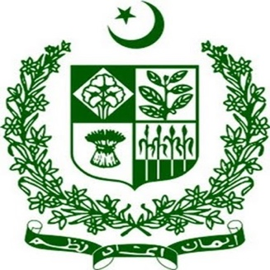
Intervention #7 by Mr. Ata ur Rehman, Additional Secretary,
Ministry of Religious Affairs
Blasphemy Law
Mr. President,
Allow me to share some thoughts on the context, necessity and safeguards vis-à-vis blasphemy laws in Pakistan.
In terms of context, blasphemy laws exist in many countries, including 20 European countries. These laws aim to foster religious harmony, peaceful coexistence, and mutual respect in society.
The Government is mindful of its responsibility to prevent the misuse or abuse of these laws by those who wish to exploit it for personal gain or unlawful purposes.
The Government takes any complaint of misuse of the Blasphemy Law seriously. It continues to undertake legal, administrative, and policy measures to prevent the misuse of this law.
Blasphemy law in Pakistan is not discriminatory as it is based on respect for all religions. It applies to Muslims and non-Muslims alike.
The fact that most of the cases of Blasphemy are against Muslim citizens proves that it is not targeted against minorities.
Mr. President,
Let me now elaborate further on the necessary safeguards built into our system against misuse of the Blasphemy Law.
- It has been made obligatory that investigation of blasphemy cases can only be done by an officer with the minimum rank of Superintendent of Police.
- Significant deterrence against false cases (imprisonment up to 7 years and fine) in our legal system under Section 211 of the Pakistan Penal Code. The Federal Investigation Agency has been empowered to pursue cases of false claims and abuse of the law.
- In prison, trials and other security measures have been taken to protect all those involved in Blasphemy related cases.
- Any capital punishment awarded by a lower Court can be challenged in the High Courts and the Supreme Court. As a last resort, a mercy petition can be submitted to the President of Pakistan.
Mr. President,
Courts have also ensured free and impartial trials, thus effectively protecting citizen rights enshrined in the Constitution.
The Supreme Court, in its judgment, has held that “criticism on misuse of blasphemy law does not amount to blasphemy itself.”
In October 2018, a three-member bench of the Supreme Court of Pakistan under Pakistan’s Chief Justice found no evidence against allegations of blasphemy by Asia Bibi and acquitted her. The acquittal was upheld in the review petition also.
Similarly, in September 2019, Mr. Wajih-ul-Hassan was also acquitted of blasphemy charges against him. Recently, the Lahore High Court acquitted Mr. Shafqat Emanuel and Ms. Shagufta Kausar.
Mr. President,
We are pleased to note that in addition to administrative and judicial steps, our civil society and religious leaders have also played an essential role in preventing the misuse of blasphemy laws.
Earlier this month in Karachi, religious leaders publicly supported a Christian woman being threatened with being falsely implicated in a blasphemy case for a personal dispute. These positive trends demonstrate increasing societal checks and balances in such situations.
Mr. President,
We remain fully committed to building an inclusive and cohesive society where all our citizens, without any distinction, enjoy and exercise their fundamental rights and freedoms, both individually and collectively.
Thank you.
* * *

