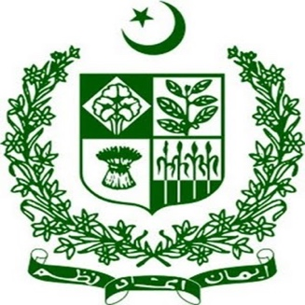
STATEMENT BY SECRETARY
MINISTRY OF HUMAN RIGHTS, Mr. Ali Raza Bhutta
Freedom of Media and Journalists Protection
Mr. President,
As the fourth pillar of democracy, Pakistan attaches great importance to an independent and vibrant media.
We believe in the free flow of information and constructive criticism as a protector of the country’s rule of law and human rights.
A liberal media policy of the Government has resulted in the exponential growth of newspapers, TV, and Radio Channels in the private sector. Over 100 TV Channels are on air daily, providing a vital platform for dialogue and discussion on wide-ranging topics of public import.
In line with our constitutional framework and international obligations, we continue to take legal, policy, and institutional measures to provide an enabling and safe environment to journalists, media professionals, and human rights activists.
We thank the National Commission for Human Rights for articulating policy guidelines on human rights defenders in 2019. These guidelines have further strengthened our domestic framework in this very important area. The enactment of the Journalists Act in 2021 is a clear example.
Now, we would like to share the various steps taken to promote the welfare and well-being of the journalist community from the devolved perspective of provinces.
Mr. President,
In 2019, the Government of KP adopted the Journalists Welfare Endowment Fund (Amendment) Act 2019 to provide for the welfare of veteran journalists of age 60 or above in case of, inter alia, death or injury.
The Government of Punjab also established a PKR 50 million fund to support affected journalists or their families with grants up to PKR 100,000. For the year 2020-21, the total beneficiaries from the fund amounted to 145, with a disbursement of PKR 7.8 million. Punjab also announced a Relief Package for Journalists amidst Covid-19 of Rs. 100,000 as a one-time grant, and widows were given Rs. 10,000/month. 89 journalists have benefitted from under this package with the disbursed amount estimated at PKR 5.5 million.
Baluchistan Information Department has established a particular “Journalist Welfare Fund” to compensate journalists for any severe injuries and cases of death to their family members.
Mr. President,
Organizations and unions championing professional rights and protecting the legitimate interests of the journalist community are fully functional in Pakistan.
The Federal and Provincial Governments stay in regular contact with these bodies and closely consult during the formulation of law and policy frameworks on press freedom.
Mr. President,
The media landscape is undergoing rapid transformation due to the advent of social media platforms. We are mindful of the new trends, challenges and complexities in this regard. Accordingly, we have been taking necessary measures to protect the right to freedom of expression and opinion while reinforcing the duties and responsibilities germane to exercising this right.
In light of the feedback from international and local human rights constituencies, we are revisiting the online social media rules and aligning these rules with principles of international law and good practices.

With this overarching approach, we take good note of the suggestions made in this important thematic area, and will thoroughly reflect on them.
Thank you.
* * *

