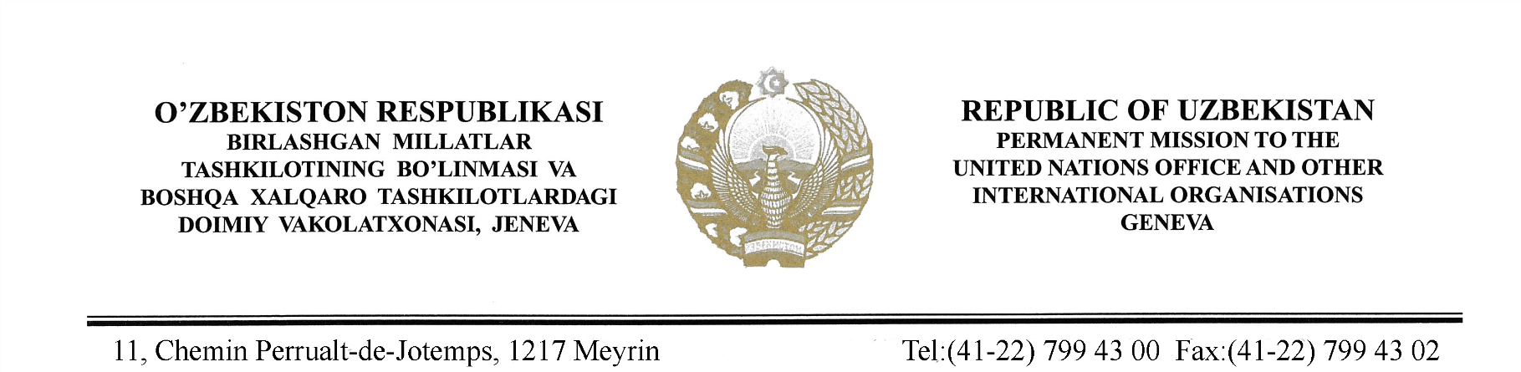

Check against delivery

STATEMENT BY THE DELEGATION OF THE REPUBLIC OF UZBEKISTAN AT THE 41st SESSION OF THE UPR WORKING GROUP CONSIDERATION OF THE UPR REPORT OF SOUTH AFRICA
(16 November 2022)

Mr. President,

Uzbekistan welcomes the Delegation of South Africa and thanks for its engagement for the 4th cycle of UPR.
We note with appreciation the steps taken by the Government for the implementation of the recommendations from the previous UPR cycles and achievements in adopting number of legal acts and action planes to protect and promote human rights.
Uzbekistan recommends to South Africa the following:
One, take measures aimed at strengthening the capacity of national human rights mechanisms, especially in protecting victims of domestic and gender-based violence;
Two, continue further engagement to ensure the right to education for all sectors of society.
We wish South Africa a successful UPR.

I thank you!

