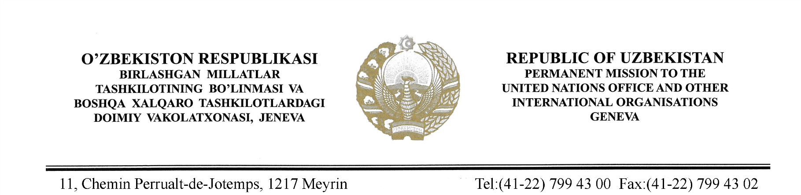

STATEMENT BY THE DELEGATION OF THE REPUBLIC OF UZBEKISTAN AT THE 41st SESSION OF THE UPR WORKING GROUP CONSIDERATION OF THE UPR REPORT OF NETHERLANDS
(15 November 2022)

Mr. President,

Uzbekistan welcomes the delegation of the Netherlands and thanks for presentation of its 4th UPR report.
We welcome the adoption of the Second National Human Rights Action Plan and measures taken by Government to enhance the representation of women in senior positions.
We also acknowledge the steps taken by the Netherlands in the areas such as ensuring labour rights, rights of peoples with disabilities and children’s rights.
Uzbekistan recommends the following:
One, continue further efforts to protect rights of migrants and vulnerable groups;
Two, take necessary measures towards addressing the violence against women, including domestic violence.
We wish Netherlands a successful UPR.

I thank you!

