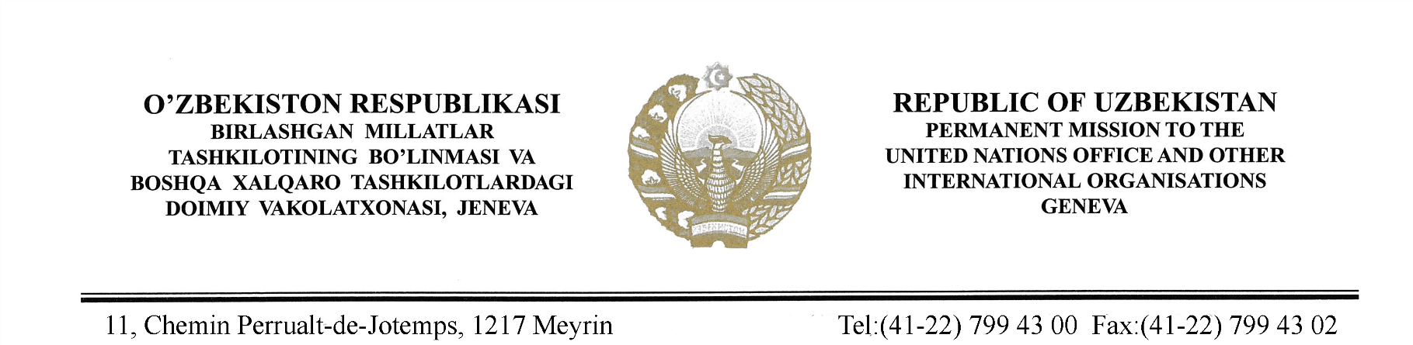

STATEMENT BY THE DELEGATION OF THE REPUBLIC OF UZBEKISTAN
AT THE 41st SESSION OF THE UPR WORKING GROUP
CONSIDERATION OF THE UPR REPORT OF POLAND
(15 November 2022)

Thank you, Mr. Vice-President,

Uzbekistan welcomes the delegation of Poland and thanks for submission of the National Report.
We commend Poland’s efforts to strengthen and support the activities of the human rights institutions in the country, namely the Commissioner for Human Rights.
We also note with appreciation the measures taken by the Government to address the gender equality issues, as well as the adoption of National Action Plan for Equal Treatment 2022-2030.
In the spirit of constructive cooperation, Uzbekistan recommends to Poland the following:
- Continue efforts on finalising reforms initiated with a view to improving the functioning of the justice system.
- Strengthen further measures to protect the rights of persons with disabilities, including within the recommendations of the Committee on the Rights of Persons with Disabilities.
We wish Poland success in its review.

Thank you.

