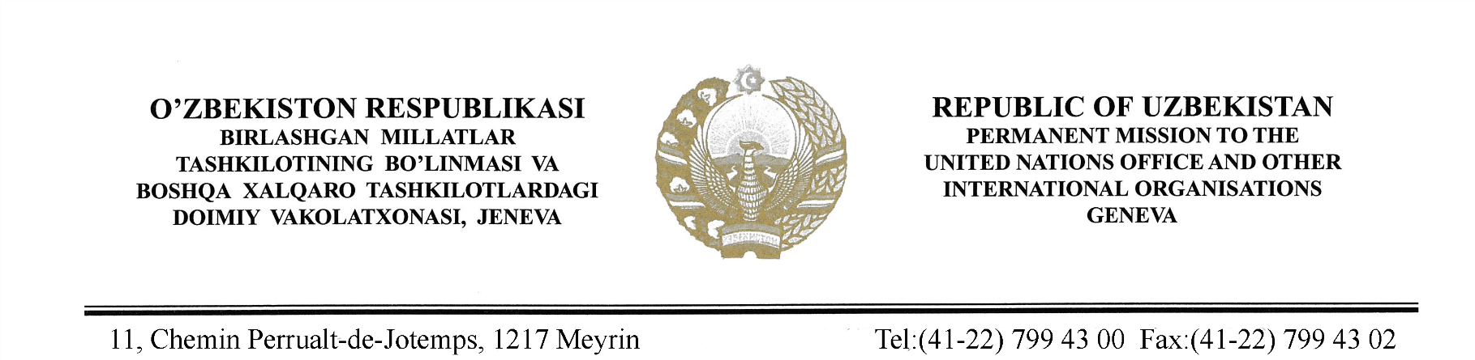

STATEMENT BY THE DELEGATION OF THE REPUBLIC OF UZBEKISTAN
AT THE 41st SESSION OF THE UPR WORKING GROUP
CONSIDERATION OF THE UPR REPORT OF BRAZIL
(14 November 2022)

Thank you, Mr. President,

Uzbekistan thanks the Delegation of Brazil for their presentation of its comprehensive national report.
We appreciate Brazil’s constructive cooperation with the UN human rights institutions.
We also commend Brazil’s efforts to launch the Aid Program under the Law adopted in December 2021, which aimed at enhancing the Government policy towards ensuring the health, education, employment and social welfare benefits to vulnerable families.
In the spirit of constructive cooperation, Uzbekistan recommends following:
- Take necessary measures to ensure human rights of vulnerable groups against all forms of violence, especially women and children.
- Implement the National Human Rights Action Plan with the view of strengthening relevant human rights institutions in the country under the Paris Principles;
We wish Brazil success in its review.

Thank you.

