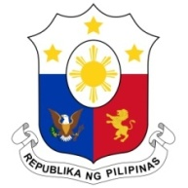
PHILIPPINES

HUMAN RIGHTS COUNCIL
41st Session of the Working Group on the Universal Periodic Review
15 November 2022, Palais des Nations, Geneva, Switzerland

REVIEW OF POLAND

Thank you, Mr. President.

The Philippines warmly welcomes the delegation of Poland and thanks it for its national report.

The Philippines welcomes the Council of Ministers’ Resolution No. 183 on the National Action Against Family Violence 2022, which underlines Poland’s commitment to implement relevant binding international instruments, as well as other measures to combat domestic violence.

We likewise positively note the sustained increase of budgetary allocation for the Commissioner of Human Rights and advances in ensuring social welfare support to women, children, and persons with disabilities.

The Philippines, in a constructive spirit, offers the following recommendations:

- Step up efforts to combat intolerance, violence and discrimination against migrants, ethnic and sexual minorities;

- Continue to consider acceding to the International Convention on the Protection of the Rights of All Migrant Workers and Members of their Families.

Lastly, we wish Poland a successful UPR.

Thank you, Mr. President. END

