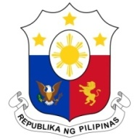
PHILIPPINES

HUMAN RIGHTS COUNCIL
27th Session of the Working Group on the Universal Periodic Review
07 November 2022, Palais des Nations, Geneva, Switzerland

REVIEW OF ECUADOR

Thank you, Chair.

The Philippines welcomes the delegation of Ecuador and thanks it for the presentation of its fourth national report.

The Philippines acknowledges the measures taken by Ecuador to address its prison system crisis by shifting to an approach based on human rights and social rehabilitation.

We express our support for Ecuador’s role in shepherding the negotiations on a legally binding instrument on TNCs and human rights and notes national efforts towards the development of a national action plan on this matter.

In a constructive spirit, the Philippines recommends the following:

- Continue enhanced implementation of policies and programs for the prevention and eradication of gender-based violence and concurrent efforts to promote the empowerment of women and girls, including the 2021-2025 Opportunity Creation Plan; and
- Sustain initiatives on poverty reduction, social inclusion and protection of groups in vulnerable situations, especially children and adolescents, migrants, and persons with disabilities.

Thank you, Chair. END

