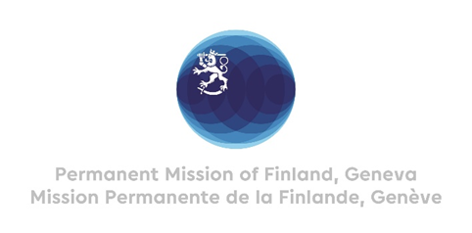

41. Session of the UPR working group Recommendations by Finland

to South Africa

16 November 2022

Mr. President,

Finland welcomes the engagement of South Africa in the UPR process. We commend the establishment of the National Strategic Plan on Gender-based Violence and recommend the following:

- Firstly, to develop measurable targets for indicators of the National Strategic Plan on Gender-based Violence and to prioritize appropriate training for professionals who work with victims of gender-based violence.
- Secondly, to ensure effective access to sexual and reproductive health and rights information, education and services.

- Thirdly, to strengthen the protection of whistle-blowers including by ensuring adequate resources for the Auditor –General and the Public Protector.

Thank you.

