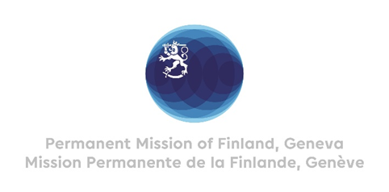

41 Session of the UPR working group Recommendations by Finland to Poland

15 November 2022

Mr. President,

Finland commends Poland for the solidarity your society has shown in helping the Ukrainian refugees. With the ongoing war, we are all reminded how important it is to safeguard rule of law and human rights.

Finland welcomes the engagement of Poland in the UPR process and wishes to recommend the following:

- Firstly, to amend its legislation to prohibit discrimination faced by sexual and gender minorities and to provide them effective legal protection against hate crimes and hate speech.

- Secondly, to recognize the key role of Human Rights defenders and activists in protecting human rights and to improve the Police code of conduct in treating the peaceful protesters.

- Thirdly, to ensure timely and effective access to sexual and reproductive health services and to refrain from criminalizing their provision.

Thank you.

