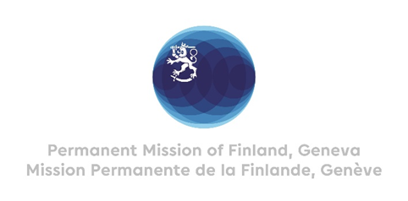

41. Session of the UPR working group Recommendations by Finland

to Brazil

14 November 2022

Mr. President,

Finland welcomes the engagement of Brazil in the UPR process. We commend Brazil for the participatory process and wish to recommend the following:

- Firstly, refrain from approving legislation that would weaken legal protection of indigenous and quilombolas territories, reserves and other environmentally protected areas.

- Secondly, continue to develop legislation and policies at federal, state and municipal level to punish and prevent hate crimes and discrimination against the LGBTI+ population.

- Thirdly, to ratify the Optional Protocol to the International Covenant on Economic, Social and Cultural Rights.

Thank you.

