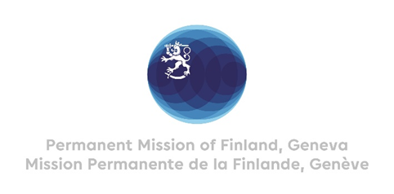

41 Session of the UPR working group Recommendations by Finland to the Philippines

14 November 2022

Mr President,

Finland welcomes the engagement of the Philippines in the UPR process and recommends the following:

- Firstly, to enact the Human Rights Defenders Bill and strengthen existing mechanisms to prevent violations against human rights defenders, including holding perpetrators accountable,

- Secondly, to pass legislation protecting LGBTIQ+ and other persons in vulnerable positions from all forms of discrimination, notably the SOGIE (Sexual Orientation, Gender Identity and Gender Expression) Equality Bill,

- Thirdly, to ensure effective implementation of the Responsible Parenthood and Reproductive Health Act,

- Fourthly, to investigate thoroughly the deaths, threats and harassment of journalists and ensure that freedom of press is not restricted by intimidation of the media.

Thank you.

