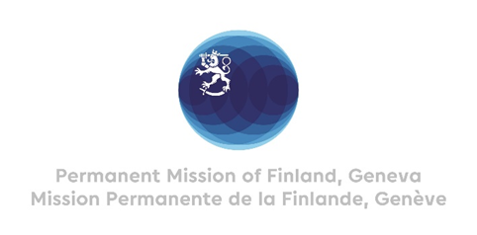

41. Session of the UPR working group Recommendations by Finland

to Algeria

11 November 2022

Mr. President,

Finland welcomes the engagement of Algeria in the UPR process and wishes to recommend the following:

- Firstly, to adopt comprehensive legislation to prevent and combat violence against women and to guarantee the implementation of the laws on gender equality and women’s rights.

- Secondly, to ensure the right to freedom of speech and expression to fully reflect commitments under international human rights law.

- Thirdly, to amend the legislation on public meetings and demonstrations to ensure the right to freedom of peaceful assembly and of association.

Thank You.

