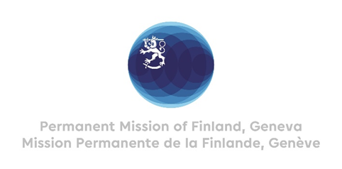
41. Session of the UPR working group
Recommendations by Finland to India
10 November 2022

Mr. President,

Finland welcomes the engagement of India in the UPR process. We welcome the ruling of the Supreme Court of India that all women can obtain abortions up to 24 weeks into their pregnancies. Finland recommends:

- Firstly, to take measures to stop violence against women with disabilities by implementing provisions of amended criminal laws pertaining to sexual violence,

- Secondly, to decentralize and simplify the Unique Disability Identity card system and its certification process,

- Thirdly, to strengthen the implementation of the Whistleblowers Protection Act 2014, and provide universal protection to the whistleblowers.

Thank you.

