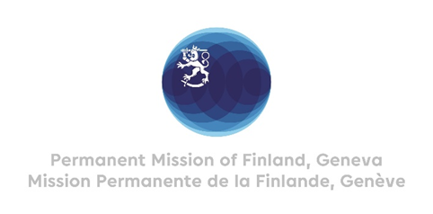

41. Session of the UPR working group Recommendations by Finland

to the United Kingdom

10 November 2022

Mr. President,

Finland welcomes the engagement of the United Kingdom in the UPR process. We commend the UK’s ratification of the Istanbul Convention. Finland wishes to recommend:

- Firstly, to dedicate sufficient resources to central, devolved and local authorities to ensure effective implementation of the Istanbul Convention.

- Secondly, to ensure that women in Northern Ireland are able to access safe abortion services on equal basis with women living in other parts of the United Kingdom.

- Thirdly, to introduce a ban on all corporal punishment of children as recommended by the CRC and other treaty bodies.

Thank you.

