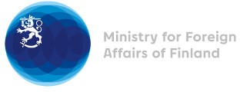

41st Session of the UPR working group Recommendations by Finland to Morocco

8 November 2022

Mr. President,

Finland highly appreciates the engagement of Morocco in the UPR process and wishes to recommend the following:

- Firstly, to ratify the Second Optional Protocol to the International Covenant on Civil and Political Rights aiming to the abolition of the death penalty
- Secondly, Finland recommends Morocco to extend an open and standing invitation to all special procedure mandate holders.
I thank you.

