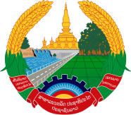
Statement by the delegation of the Permanent Mission of the Lao PDR to the United Nations Office and other International Organizations in Geneva
At the 41st Session of the UPR Working Group
Geneva, 7-18 November 2022
_________

Review of the Republic of India, 10 November 2022 (14:30-18:00 hours)

- Mr. President,

- The Lao PDR warmly welcomes and thanks the delegation of India for the comprehensive report.

- My delegation appreciates the progress made by India in advancing the fulfilment of human rights of its citizens, particularly in the fields of poverty reduction, education, health, access to housing and safe drinking water with a focus on vulnerable groups, including women and children.

- The Lao PDR would like to make two recommendations:

- Strengthening the implementation of national development strategies towards achieving sustainable development and poverty eradication.

- Continuing efforts to ensure equal access to quality education for all children.

- I wish India a success in this UPR.

- I thank you, Mr. President.

