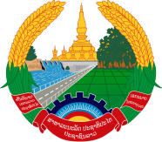
Statement by H.E. Mr. Latsamy KEOMANY, Ambassador/Permanent Representative of the Lao PDR to the United Nations Office and other International Organizations in Geneva
At the 41st Session of the UPR Working Group
Geneva, 7-18 November 2022
_________

Review of the Republic of Indonesia, 9 November 2022 (9:00-12:30 hours)

- Mr. President,

- The Lao PDR would like to thank Indonesia for the comprehensive report.

- My delegation commends the remarkable progress made by Indonesia in the promotion and protection of human rights, among others, the improvements in fulfilling the rights of vulnerable and marginalized groups, including women, children, persons with disabilities, and the elderly.

- On the way forward, the Lao PDR would like to make two recommendations:

- Strengthening measures to ensure the full and effective implementation of women's empowerment and child protection priority plans; and

- Redoubling efforts to narrow the socio-economic development gap between urban and rural areas.

- I wish Indonesia a success in this UPR.
- I thank you.

