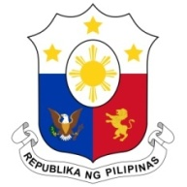
PHILIPPINES

HUMAN RIGHTS COUNCIL
27th Session of the Working Group on the Universal Periodic Review
09 November 2022, Palais des Nations, Geneva, Switzerland

REVIEW OF INDONESIA

Thank you, Mr. Chair.

The Philippines welcomes Indonesia’s 5th generation of NAP-HR 2021-2025 focusing on the promotion of the rights of women, children, persons with disabilities, and “Adat” Communities.
We likewise commend the promulgation of legislative measures and regulations aimed at enhancing the government’s policy on combating violence against women and children, including the Sexual Violence Crime Law of 2022.
My delegation, in the spirit of amity and cooperation, recommends that Indonesia:
- Sustain consultations with stakeholders on the ratification of the ILO Convention 189, OP ICCPR, and OP CEDAW;
- Further enhance gender-responsive budgeting in national and local level policy planning; and
- Continue to engage the NHRI, civil society organizations and other stakeholders on the enhancement of national human rights mechanisms.

We wish Indonesia success in its UPR.
Thank you, Chair. END

