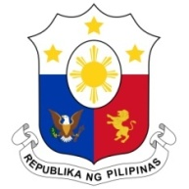
PHILIPPINES

HUMAN RIGHTS COUNCIL
41st Session of the Working Group on the Universal Periodic Review
07 November 2022, Palais des Nations, Geneva, Switzerland

REVIEW OF TUNISIA

Thank you, Chair.

The Philippines commends Tunisia for giving due regard to recommendations in the last review to harmonize domestic laws with its new Constitution and international human rights standards.

The Philippines likewise commends Tunisia for continuing to invest in the improvement of its public education system.

In a constructive spirit, the Philippines recommends that Tunisia:

- Sustain efforts to address the issue of school dropouts and promote greater access to quality education through the wider use of information communications technology, among other measures; and

- Further promote maternal and child health, including through strengthened implementation of the National Strategy for the Advancement of Maternal and Newborn Health 2020-2024.

Thank you, Chair. END

