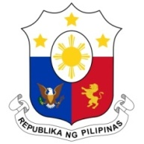
PHILIPPINES

HUMAN RIGHTS COUNCIL
41st Session of the Working Group on the Universal Periodic Review
08 November 2022, Palais des Nations, Geneva, Switzerland

REVIEW OF MOROCCO

Thank you, Chair.

The Philippines notes with appreciation Morocco’s ratification of the First Optional Protocol to the ICCPR, the Optional Protocol to CEDAW and three ILO conventions.

We commend Morocco for enacting legislations strengthening institutional frameworks for the promotion and protection of human rights and the mainstreaming of human rights in governance.

We reiterate our recommendation for Morocco to ratify the Domestic Workers Convention 2011 of the International Labour Organization.
We likewise recommend enhanced efforts on women’s economic empowerment and in combatting gender-based discrimination and violence, as well as addressing the problem of child marriage.
We wish Morocco success in the implementation of accepted recommendations.
Thank you, Chair.

