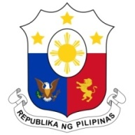
PHILIPPINES

HUMAN RIGHTS COUNCIL
41st Session of the Working Group on the Universal Periodic Review
11 November 2022, Palais des Nations, Geneva, Switzerland

REVIEW OF ALGERIA

Thank you, Mr. Chair.

The Philippines welcomes the delegation of Algeria and the presentation of its national report.

The Philippines welcomes Algeria’s sustained efforts to advance sustainable development laying a strong foundation for the full enjoyment of human rights of its people. We positively note the recognition of the right to a healthy environment in Algeria’s Constitution and the mainstreaming of the concept of sustainable development in its national development agenda.

We also commend Alegria’s accomplishments in the area of education and public health, particularly the realization of a high enrolment rate at 98.5% and improvements in its public health infrastructure.

In a constructive spirit, the Philippines offers the following recommendations:
- Continue to expand access to quality education of persons with disabilities; and
- Continue investing in and improving the delivery of public health services, especially in the field of maternal and child health.

Thank you, Mr. Chair. END

