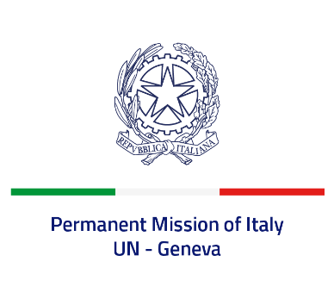
Check against delivery
UPR 41 – South Africa
Wednesday 16 November 2022, 9:00 – 12:30

Delivered by: Ambassador Gian Lorenzo Cornado, Permanent Representative of Italy

(Focal point: Daniele Borrelli, First Counsellor)

Thank you, Mister President.

We thank the distinguished delegation of South Africa for their national report and presentation.

Italy welcomes the ratification of the Optional Protocol to the Convention against Torture and other Cruel, Inhuman or Degrading Treatment or Punishment.

Italy also welcomes the efforts to combat violence against women and domestic violence, including through the first National Strategic Plan on gender-based violence and femicide (NSP-GBVF).

Italy would like to offer the following recommendations:

- Continue to strengthen efforts to prevent and combat all forms of discrimination and violence against women and girls.
- Ensure an enabling and safe environment for freedom of expression, association and peaceful assembly.
We wish the delegation of South Africa a successful review.

I thank you.

