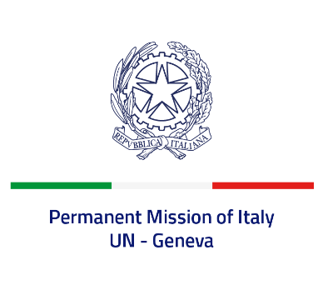
Check against delivery
UPR 41 - Netherlands
Tuesday 15 November 2022, 14:30 - 18:00

Delivered by: Ambassador Gian Lorenzo Cornado, Permanent Representative of Italy

(Focal point: Angela Zanca, First Secretary)

Thank you, Mister President.

We thank the distinguished delegation of the Kingdom of the Netherlands for its national report and presentation.

Italy commends the Kingdom of the Netherlands for its commitment to promoting and protecting human rights.

We particularly praise the Netherlands’ efforts to fight discrimination and racism, and to combat antisemitism, also thanks to the appointment of national coordinators, as well as to counter hate speech.

Italy seizes this opportunity to offer the Kingdom of the Netherlands the following recommendations:

- Sign and ratify the Optional Protocol to the Convention on the Rights of Persons with Disabilities and the Optional Protocol to the Convention on the Rights of the Child on a communications procedure;
- Ratify the Optional Protocol to the International Covenant on Economic, Social and Cultural Rights, signed in 2009.

We wish the Kingdom of the Netherlands a successful review.

I thank you.

