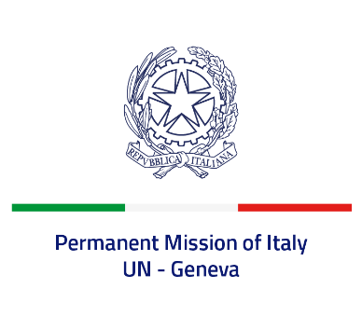
Check against delivery
UPR 41 – Poland
Tuesday 15 November 2022, 9:00 – 12:30

Delivered by: Ambassador Gian Lorenzo Cornado, Permanent Representative of Italy

(Focal point: Daniele Borrelli, First Counsellor)

Thank you, Mister President.

We thank the distinguished delegation of Poland for their national report and presentation.

Italy commends Poland for its commitment to ensuring the protection and promotion of human rights globally as a current member of the Human Rights Council.

Italy welcomes the efforts to combat violence against women and domestic violence, including through the National Action Plan Against Family Violence 2022. Italy also acknowledges the positive evaluation by the Group of Experts on Action against Violence against Women and Domestic Violence – GREVIO on the implementation of the Convention on preventing and combating violence against women and domestic violence, especially in the area of criminal law and procedure.

Italy would like to offer the following recommendations:

- Sign and ratify the Optional Protocol to the International Covenant on Economic, Social and Cultural Rights
- Sign and ratify the Optional Protocol to the Convention on the Rights of Persons with Disabilities
We wish the delegation of Poland a successful review.

I thank you.

