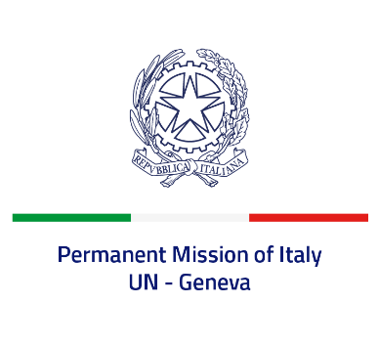
Check against delivery
UPR 41 - Brazil
Monday 14 November 2022, 14:30 - 18:00

Delivered by: Ambassador Gian Lorenzo Cornado, Permanent Representative of Italy

(Focal point: Angela Zanca, First Secretary)

Thank you, Mister President.

We thank the distinguished delegation of Brazil for its national report and presentation.

Italy welcomes the ratification by Brazil of the Optional Protocol to the Convention on the Rights of the Child on a Communications Procedure in 2017.

We also commend Brazil’s cooperation with regional and international mechanisms for the protection of human rights, including with the Special Procedures established by this Council.

Italy seizes this opportunity to offer Brazil the following recommendations:

- Ensure an enabling environment for civil society and guarantee freedom of expression, association and peaceful assembly;
- Strengthen efforts to prevent and combat sexual and gender-based violence and provide support and services for women and girls victims of violence;
- Take all necessary measures to prevent and combat human trafficking.

We wish Brazil a successful review.

I thank you.

