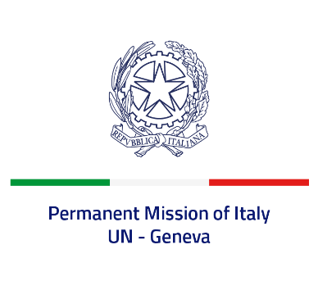
Check against delivery
UPR 41 - Philippines
Monday 14 November 2022, 9:00 - 12:30

Delivered by: Ambassador Gian Lorenzo Cornado, Permanent Representative of Italy

(Focal point: Angela Zanca, First Secretary)

Thank you, Mister President.

We thank the distinguished delegation of the Philippines for its national report and presentation.

Italy recognizes the steps undertaken by the Philippines in order to advance gender equality and women and girls’ rights, as well as to prevent and combat discrimination and violence against them, such as the adoption of the 2019 “Safe Spaces” Act and the 2021 Act criminalizing child marriages.

Italy seizes this opportunity to offer the Philippines the following recommendations:

- Ensure a safe and enabling environment for civil society and ensure freedom of expression, association and peaceful assembly, and media freedom;
- Ratify the International Convention for the Protection of all Persons from Enforced Disappearance;
- Further strengthen the measures to protect the rights of children. Prevent and combat all forms of violence and abuse against them.

We wish the Philippines a successful review.

I thank you.

