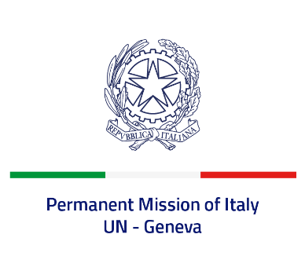
Check against delivery
UPR 41 - Algeria
Friday 11 November 2022, 9:00 - 12:30

Delivered by: Ambassador Gian Lorenzo Cornado, Permanent Representative of Italy

(Focal point: Angela Zanca, First Secretary)

Thank you, Mister President.

We thank the distinguished delegation of Algeria for their presentation.

Italy recognizes the efforts made by Algeria to prevent and combat trafficking in persons, including the recent adoption of a National Action Plan.

Italy seizes this opportunity to offer Algeria the following recommendations:

- Consider establishing a de jure moratorium on capital executions with a view to fully abolishing death penalty.
- Take concrete measures to prevent and combat all forms of discrimination and violence against women and girls, and provide victims with adequate assistance.
- Ensure a safe and enabling environment for civil society, as well as freedoms of expression, association and peaceful assembly, and media freedom.
- Ensure the rights of people belonging to religious or belief minorities, and refrain from any discriminatory legislation or practice against them.

We wish Algeria a successful review.

I thank you.

