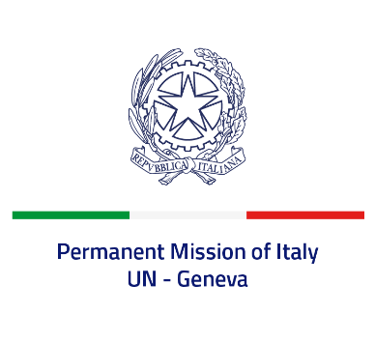
Check against delivery
UPR 41 – United Kingdom of Great Britain and Northern Ireland
Thursday 10 November 2022, 9:00 – 12:30

Delivered by: Ambassador Gian Lorenzo Cornado, Permanent Representative of Italy

(Focal point: Daniele Borrelli, First Counsellor)

Thank you, Mister President.

We thank the distinguished delegation of the United Kingdom for their national report and presentation.

Italy commends the United Kingdom for its commitment to ensuring the protection and promotion of human rights globally as a current member of the Human Rights Council.

Italy welcomes the recent ratification of the Council of Europe Convention on preventing and combating violence against women and domestic violence.

Italy seizes this opportunity to offer the United Kingdom the following recommendations:

- Ratify the International Convention for the Protection of all Persons from Enforced Disappearance;
- Keep under review the reservations registered upon ratification of the Council of Europe Convention on preventing and combating violence against women and domestic violence (Istanbul Convention).

We wish the United Kingdom a successful review.

I thank you.

