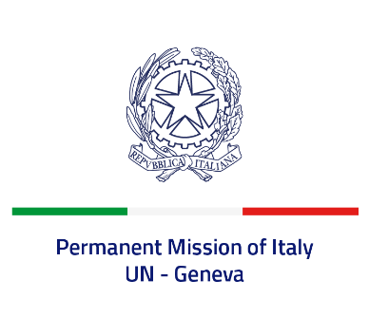
Check against delivery
UPR 41 – Finland
Wednesday 9 November 2022, 14:30 – 18:00

Delivered by: Ambassador Gian Lorenzo Cornado, Permanent Representative of Italy

(Focal point: Daniele Borrelli, First Counsellor)

Thank you, Mister President.

We thank the distinguished delegation of Finland for their national report and presentation.

Italy commends Finland for its commitment to ensuring the protection and promotion of human rights globally as a current member of the Human Rights Council.

While noting that domestic violence is indicated also in the national report as one of the most persistent human rights problems in Finnish society, Italy welcomes the efforts to address this phenomenon, as well as to combat gender-based violence and violence against women, including through the Action Plans for the Implementation of the Istanbul Convention.

Italy seizes this opportunity to offer Finland the following recommendations:

- Continue to strengthen efforts to ratify the International Convention for the Protection of All Persons from Enforced Disappearance
- Continue efforts to prevent and combat domestic violence
We wish the delegation of Finland a successful review.

I thank you.

