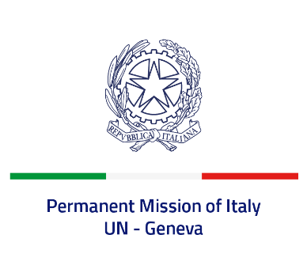
Check against delivery
UPR 41 - Indonesia
Wednesday 9 November 2022, 9:00 - 12:30

Delivered by: Minister Marie Sol Fulci, Deputy Permanent Representative of Italy

(Focal point: Angela Zanca, First Secretary)

Thank you, Mister President.

We thank the distinguished delegation of Indonesia for their national report and presentation.

Italy recognizes the steps undertaken by Indonesia in order to advance its legal and institutional frameworks on human rights, including through the adoption of its fifth National Action Plan for Human Rights, and with particular regard to the elimination of violence against children and the mainstreaming of the rights of persons with disabilities.

Italy seizes this opportunity to offer Indonesia the following recommendations:

- Consider establishing a de jure moratorium on capital executions, with a view to fully abolishing death penalty;
- Guarantee freedom of religion or belief and the rights of persons belonging to minorities, and ensure accountability for violations;
- Ensure a safe and enabling environment for civil society, as well as freedom of expression and media freedom;
- Strengthen efforts to protect women and girls’ rights and fight against all forms of discrimination and gender-based violence.

We wish Indonesia a successful review.

I thank you.

