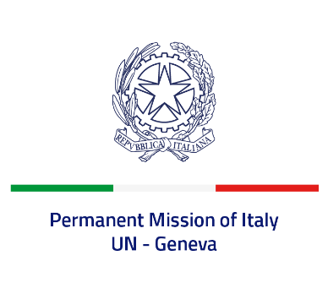
Check against delivery
UPR 41 - Morocco
Tuesday 8 November 2022, 14:30 - 18:00

Delivered by: Ambassador Gian Lorenzo Cornado, Permanent Representative of Italy

(Focal point: Angela Zanca, First Secretary)

Thank you, Mister President.

We thank the distinguished delegation of Morocco for their national report and presentation.

We commend Morocco for the ratification of the First Optional Protocol to the ICCPR and the Optional Protocol to the Convention on the Elimination of All Forms of Discrimination against Women.

We also recognize the establishment of a National Mechanism for the Prevention of Torture and of a National Mechanism for the Protection of Persons with Disabilities.

Italy seizes this opportunity to offer Morocco the following recommendations:

- Consider adopting a de jure moratorium of capital executions and continue national discussions with a view to abolishing the death penalty;
- Continue to take measures to combat all forms of violence and discrimination against children, women and girls, including early and forced marriage.
- Ensure a safe and enabling environment for civil society, as well as freedom of expression, peaceful assembly and association;

We wish Morocco a successful review.

I thank you.

