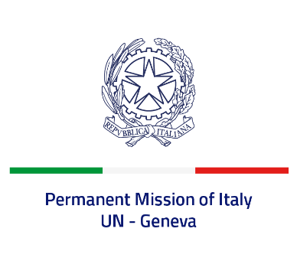
Check against delivery
UPR 41 - Tunisia
Tuesday 8 November 2022, 9:00 - 12:30

Delivered by: Ambassador Gian Lorenzo Cornado, Permanent Representative of Italy

(Focal point: Angela Zanca, First Secretary)

Thank you, Mister President.

We thank the distinguished delegation of Tunisia and commend Tunisia’s commitment to the UPR process, as well as its engagement with the international human rights mechanisms, especially the UN Treaty Bodies and Special Procedures.

Italy seizes this opportunity to offer Tunisia the following recommendations:

- Consider adopting a de jure moratorium of capital executions, with a view to fully abolishing the death penalty;
- Strengthen efforts to promote gender equality and combat all forms of gender-based violence, including child, early and forced marriage;
- Ensure a safe and enabling environment for civil society, as well as freedom of expression and of the press, peaceful assembly and association; this is all the more crucial in the implementation of the political roadmap and in view of the elections of the 17th December;

We wish Tunisia a successful review.

I thank you.

