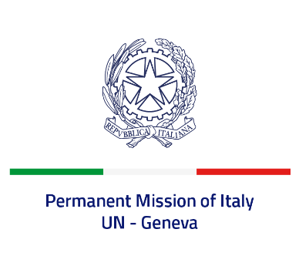
Check against delivery
UPR 41 – Ecuador
Monday 7 November 2022, 14:30 – 18:00

Delivered by: Ambassador Gian Lorenzo Cornado, Permanent Representative of Italy

(Focal point: Daniele Borrelli, First Counsellor)

Thank you, Mister President.

We thank the distinguished delegation of Ecuador for their national report and presentation.

Italy welcomes the efforts to improve the protection of freedom of expression, including through the amendment of the Organic Law on Communication.
Italy seizes this opportunity to offer Ecuador the following recommendations:

- Step up efforts to promote gender equality and eliminate all forms of violence and discrimination against women and girls, including harmful practices, like children, early and forced marriage.
- Continue efforts to prevent and combat all forms of discrimination and violence against persons belonging to minorities, indigenous people and other persons and groups in vulnerable situations.

We wish Ecuador a successful review.

I thank you.

