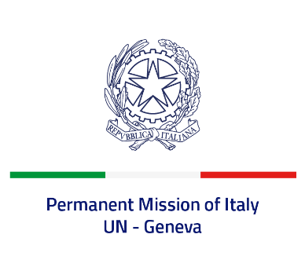
Check against delivery
UPR 41 – Bahrain
Monday 7 November 2022, 9:00 – 12:30

Delivered by: Ambassador Gian Lorenzo Cornado, Permanent Representative of Italy

(Focal point: Daniele Borrelli, First Counsellor)

Thank you, Mister President.

We thank the distinguished delegation of Bahrain for their national report and presentation.

Italy welcomes the adoption of the National Human Rights Plan 2022-2026 as well as the measures to increase women’s empowerment and enhance their participation in public life and labour market.
Italy seizes this opportunity to offer Bahrain the following recommendations:

- Consider adopting a de jure moratorium of capital executions with a view to fully abolishing the death penalty for all crimes.
- Take measures to further limit all forms of torture - including ratifying the Optional Protocol to the Convention Against Torture - and ensure full accountability for violations and abuses.
- Continue efforts aimed at creating a safer and enabling environment for increasing levels of freedom of expression, association and peaceful assembly.

We wish Bahrain a successful review.

I thank you.

