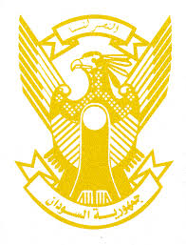
Sudan’s Statement on the Philippine’s Universal Periodic Review during 41st UPR Working Group
Delivered by
H.E Ambassador Hassan Hamid Hassan Permanent Representative of
the Republic of the Sudan
14 November 2022
ــــــــــــــــــــــــــــــــــــــــــــــــــــــــــــــــــــــــــــــــــــــــــــــــــــــــــــــــــــــــــــــــــــــــــــ
Thank you, Excellency,

Sudan welcomes the Philippine’s delegation and thank them for their report.
Sudan appreciates the positive steps taken by Philippine including ensuring the civic space through protecting and promoting the freedoms of media, expression, association, cooperating with NGOs, holding the national election in May 2022. We welcome the legislative reform efforts, and the implementation of the Philippine Development Plan 2017-20222.
Sudan recommends the Philippine to continue its efforts to ensure the rights to development and implementation of SDGs.
We wish to the Philippine all success and continuous progress.

