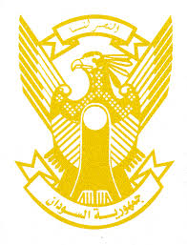
Sudan’s Statement on Brazil’s Universal Periodic Review during 41st UPR Working Group
Delivered by
H.E Ambassador Hassan Hamid Hassan Permanent Representative of the Republic of the Sudan
14 November 2022
ــــــــــــــــــــــــــــــــــــــــــــــــــــــــــــــــــــــــــــــــــــــــــــــــــــــــــــــــــــــــــــــــــــــــــــ
Thank you, Excellency,

Sudan welcomes Brazilian delegation and thank them for their report.
Sudan appreciates the positive steps taken by Brazil in the context of promotion and protection of human rights including adopting rights-based approach in response to Covid-19 pandemic, engaging positively with regional and international human rights mechanism. We highly appreciate inclusion of Afro-Brazilian history and culture in the official educational curriculum.
Sudan recommends Brazil to continue its efforts aimed provision of healthcare, education services and poverty alleviation programs, especially in rural areas.
We wish Brazil all success and continuous progress.

