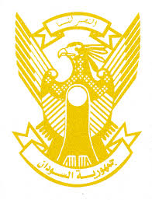
Sudan’s Statement on UK’s Universal Periodic Review during 41st UPR Working Group
Delivered by
H.E Ambassador Hassan Hamid Hassan Permanent Representative of the Republic of the Sudan
10 November 2022
ــــــــــــــــــــــــــــــــــــــــــــــــــــــــــــــــــــــــــــــــــــــــــــــــــــــــــــــــــــــــــــــــــــــــــــ
Thank you, Excellency,

Sudan welcomes the UK’s delegation and thank them for their report. We appreciate UK’s fulfilment in submitting human rights’ conventions reports, enacting domestic abuse act in 2021, adoption of its National Plan on Human Rights and Business, strategy against sexual exploitation as well as measures taken to protect women, children, minorities and vulnerable groups.
Sudan highly appreciates the valuable financial contribution by the UK to women and children protection projects worldwide, including my country.
Sudan recommend that UK consider accession to convention on protection of all persons from Enforced Disappearance.
We wish to the UK all success and continuous progress.

