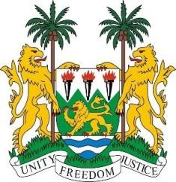
SIERRA LEONE

41st Session of the UPR
(7th – 18th November 2022)

SOUTH AFRICA

16 November 2022

Mr President,

Sierra Leone conveys warm fraternal greetings and welcomes the Hon. John Jeffery, Deputy Minister of Justice and Constitutional Development and the esteemed high-level delegation from the sister Republic of South Africa to this review cycle and thanks them for their presentation.

South Africa as a constitutional democracy is such a very diverse, multi-ethnic, multi-linguistic and pluralistic society. We note with interest that South Africa released over 15,000 low-risk inmates and has reduced overcrowding within its prison system by 28%. In addition, we commend South Africa for its continued commitment in upholding and protecting the Nelson Mandela Rules both domestically and internationally.

Sierra Leone is concerned about the epidemiology of child homicide in South Africa and calls for government`s decisive action in this regard.

Whiles noting South Africa`s stunning human rights progress we note there are gaps like all other countries and therefore recommend as follows:

- Expedite the legislative process and enact into law of all bills on hate crimes and rights of persons with disabilities particularly persons with albinism.

- Take concrete measures in eliminating child, early and forced marriages.

- Ratify the African Disability Protocol.

Finally, Sierra Leone wishes South Africa every success in this review cycle.

Thank you, Mr President.

