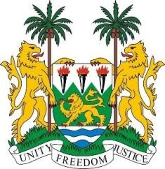
SIERRA LEONE

41st Session of the UPR

THE KINGDOM OF THE NETHERLANDS

15 November 2022

Mr President,

Sierra Leone welcomes the delegation from the Netherlands and thanks them for their presentation.

My delegation notes with interest the adoption in 2019 of the second National Action Plans on Children’s Rights, as well as the ongoing efforts to increase accessibility of government services to all citizens. Sierra Leone congratulates the Netherlands for receiving an A-score in the Global Slavery Index for its fight against human trafficking.

We welcome steps taken to address discrimination, including the appointment of a National Coordinator against Discrimination and Racism, as well as the appointment of a National Coordinator on Combating Antisemitism.

Sierra Leone encourages the Netherlands to continue to actively work to addressing discrimination against minorities and migrants on the basis of race and religion, and to prosecute perpetrators of hate crimes.

We note that the Netherlands has consistently contributed to the OHCHR since 2012 and continue to support various UN (Trust Fund) initiatives. Sierra Leone is hopeful that the Netherlands will continue these supports as well as the level of its ODA at 0.7% of GNI.

Whiles noting the Kingdom`s progress, we recommend as follows:

- Review anti-discrimination legislation to ensure that it provides full and effective protection against discrimination, and adopt a definition of racial discrimination that encompasses human rights law.

- Consider to ratify both Optional Protocol to the Convention on the Rights of the Child on a communications procedure and the Migrant Workers Convention.

- Implement an integrated approach to address causes and effects of racial discrimination.

Sierra Leone wishes the Kingdom of the Netherlands every success in this review cycle.

Thank you, Mr President.

