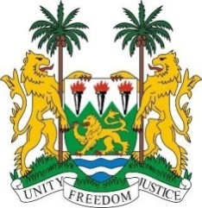
SIERRA LEONE
41st Session of the UPR (7 -18 November 2022)

UPR Review of Poland

15th November 2022
Mr. President

Sierra Leone warmly welcomes the delegation of Poland and thanks them for the comprehensive presentation of its national report.

Sierra Leone commends Poland’s continued commitment in its effort to promote and protect human rights through enactment of various human rights-related legislations, policies and programmes at the national level. We welcome Poland’s National Action Plan for Equal Treatment 2022-2030 and the activities focused on supporting vulnerable persons.

We also applaud Poland’s commitment and increased contribution to development assistance programmes, including contributions to international organizations.

In the spirit of dialogue and constructive cooperation, Sierra Leone recommends the following to Poland:

- Consider ratifying the International Convention on the Protection of the Rights of All Migrant Workers and Members of Their Families, the International Convention for the Protection of All Persons from Enforced Disappearance.

- Continue to ensure equal access to inclusive education for all children

- Take concrete steps to combat racist hate speech, incitement to hatred and hate crimes, address prejudices and negative sentiments towards national and ethnic minorities, migrants, refugees and asylum-seekers

- Ensure that all refugees enjoy the same treatment regardless of their race, ethnicity, or religion.

We wish the delegation of Poland a successful review

Thank you, Mr. President.

