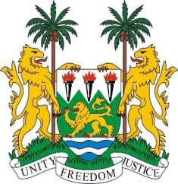
SIERRA LEONE

41st Session of the UPR

INDIA

10 November 2022

Mr. President,

Sierra Leone welcomes the high-level delegation from India to this review cycle and thanks them for their presentation.

India is widely acknowledged as being a very diverse, multi-ethnic, multi-linguistic and pluralistic society. We applaud the sense of cohesive functioning of its many interlinked organs, and for establishing the National Guidelines on Responsible Business Conduct and the consolidation of its labour codes.

Sierra Leone also notes that India has consistently contributed to the OHCHR since 2012. We welcome its commitment to continue working with the U.N. and international partners to combat human rights violations.

My delegation is concerned about incidents of sexual violence against women and urges India to intensify its efforts to address this menace.

Recommendations:

- Continue to raise public awareness about the prohibition of caste-based discrimination
- strengthen efforts to combat and eliminate child, early and forced marriages.
- Devote further attention to intersectional effects of poverty on women’s healthcare in Adivasi, Tribal, Dalit, and other communities.

Sierra Leone wishes India every success in this fourth review cycle.

Thank you, Mr President.

