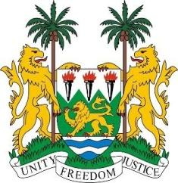
SIERRA LEONE
41st Session of the UPR

United Kingdom of Great Britain and Northern Ireland

10th November 2022

Mr. President,

Sierra Leone welcomes the distinguished high level delegation of the United Kingdom of Great Britain and Northern Ireland and thanks them for their comprehensive and insightful presentation this morning.

We welcome the UK government`s firm and unequivocal approach in addressing hate crimes. The tabling before the parliament of the Online Safety Bill; once passed into law will decisively deal with the scourge. We note that the law will provide safeguards for free speech.

We applaud the UK government`s commitment to international climate finance in the sum of 11.6 billion pounds. We further welcome the UK government`s pledge in supporting developing countries deal with climate change.

We note the tremendous strides taken in addressing prison conditions in both England and Wales including the provision of skills training to prisoners. We welcome the Scottish government`s effort in advancing race equality particularly the publication of its final report on Race Equality Action Plan.

In a spirit of constructive engagement, we recommend for the UK
Government`s consideration:

- Ratify the Migrant workers Convention or (ICPRMW) and the ICPPED).
- Consider to withdraw its interpretative declaration under Article 4 of the ICEFRD
- Consider to withdraw its reservation on CEDAW.
- Extend the applicability of the Equality Act of 2010 to Northern Ireland
- Take concrete steps in addressing structural forms of racial discrimination.

Sierra Leone wishes the UK a successful review.

Thank you, Mr. Vice President.

