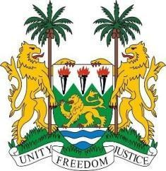
SIERRA LEONE
41st Session of the UPR

MOROCCO

8 November 2022

Mr President,

Sierra Leone welcomes the distinguished high-level delegation of the Kingdom of Morocco and thanks them for their presentation.

My delegation commends the Moroccan government for suspending the enforcement of the death penalty and establishing the Urash Programme, which aims at creating over 200,000 jobs within the next two years. We also applaud the government for expanding national social welfare programs, such as health insurance and unemployment benefits. We applaud the government`s series of policies aimed at tackling external asymmetry including inflation and improving public finances. We applaud the Kingdom`s long-term party pluralism and its socio-economic and human development strategy.

We recommend as follows:

- Consider to abolish the death penalty
- Amend the Family Code to guarantee equal rights between men and women at the dissolution of marriage, in relation to children and inheritance.
- Consider to align the minimum legal working age in the Labour Code and the school-leaving age in the 2019 Framework Act at 16 to ensure school attendance.

Sierra Leone wishes Morocco a successful review.

Thank you, Mr President.

