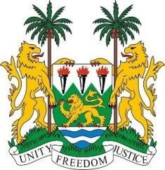
SIERRA LEONE
41st Session of the UPR

BAHRAIN

7 November 2022

Mr President,

Sierra Leone welcomes the distinguished delegation of Bahrain and thanks them for their presentation.

My delegation commends the Bahraini government for establishing the Private Sector Labour Code and specialised courts for children to ensure privacy and quality of proceedings for cases involving minors. We also applaud the government for enacting new legislation that criminalises acts of servitude and forced labour.

Recommendations:

- Abolish the death penalty for drug crimes, treason, and high treason.
- Define sexual violence and marital rape as criminal offenses in the criminal code.
- Amend the Citizenship Law of 1963 prohibiting the passage of citizenship from a woman to her child.

To conclude, Sierra Leone wishes Bahrain a successful conclusion to their UPR.

Thank you, Mr President.

